- Q2. Refactor a poorly commented Python function using an AI assistant for automatic documentation. Evaluate clarity and completeness versus manual comments.
(Each question carries 5 marks)
Prompt:
Implement Code for Refactor a poorly commented Python function using an AI assistant for automatic documentation. Evaluate clarity and completeness versus manual comments. Take inputs from user
Code:
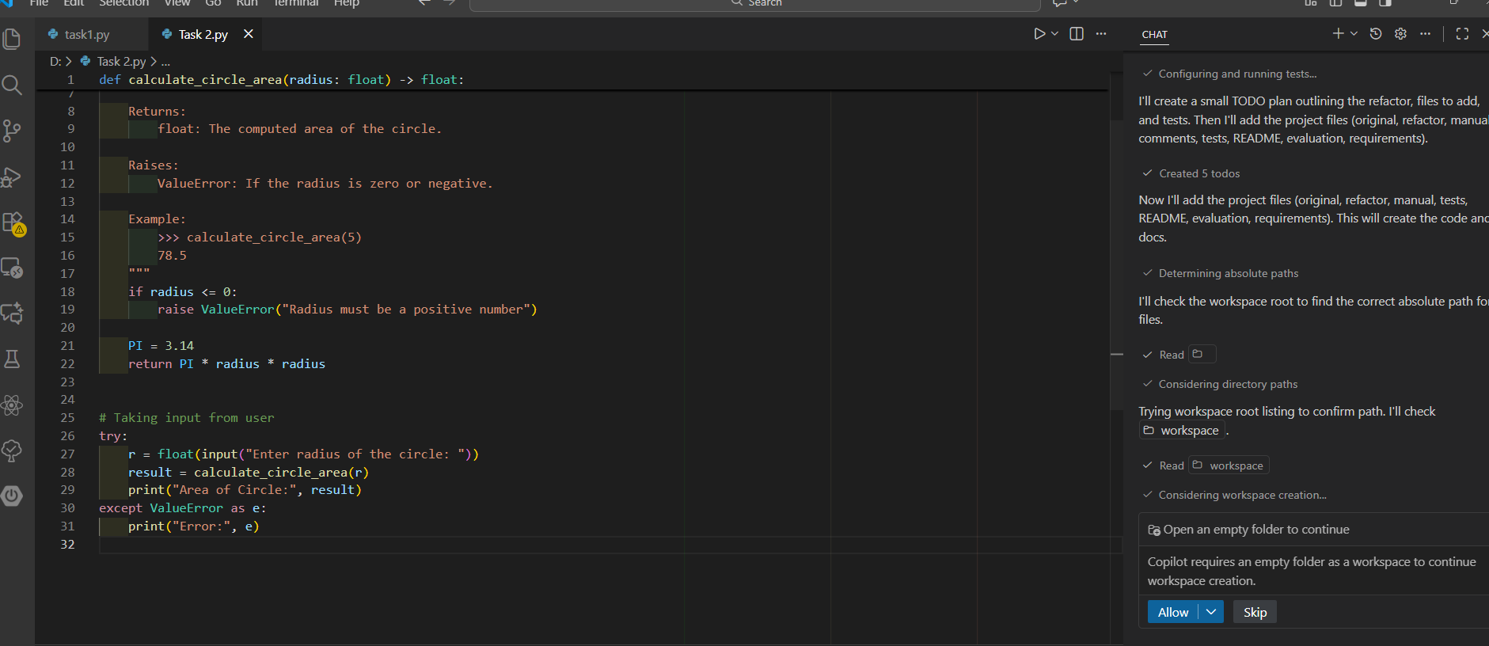
Output:
